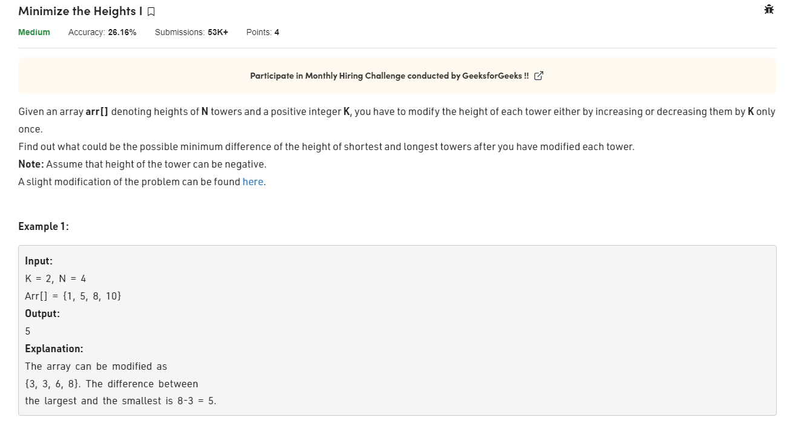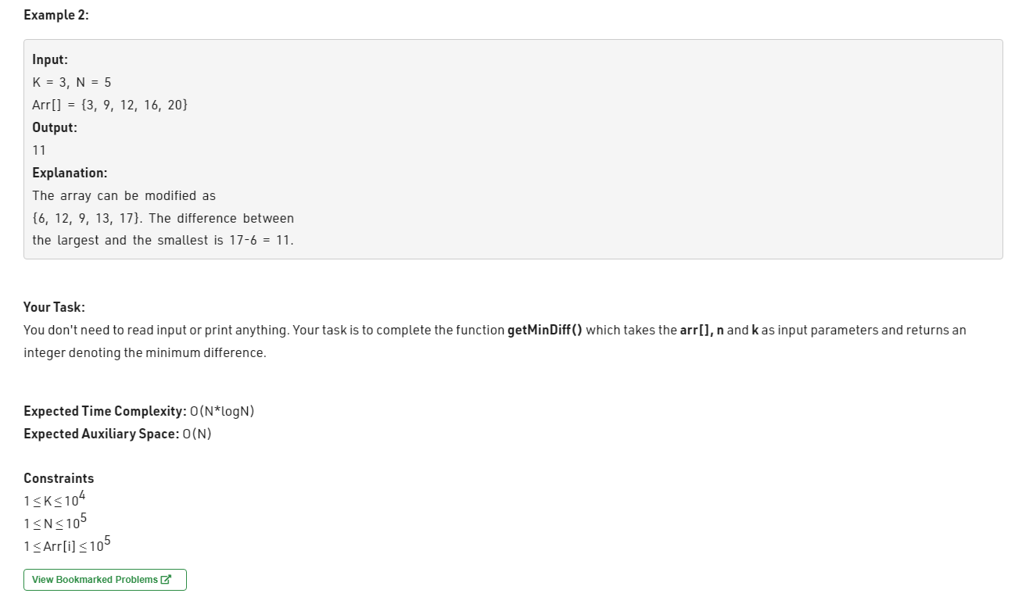

class Solution {

int getMinDiff(int[] arr, int n, int k) {

// code here

Arrays.sort(arr);

int minimum, maximum;

int result = arr[n-1]-arr[0];

for(int i=1; i<n; i++){

maximum = Math.max(arr[i-1]+k,arr[n-1]-k);

minimum = Math.min(arr[0]+k, arr[i]-k);

result = Math.min(result, maximum-minimum);

}

return result;

}

}